Nick Forleo

SWENG837

**State Diagram (Landscape at Bottom)**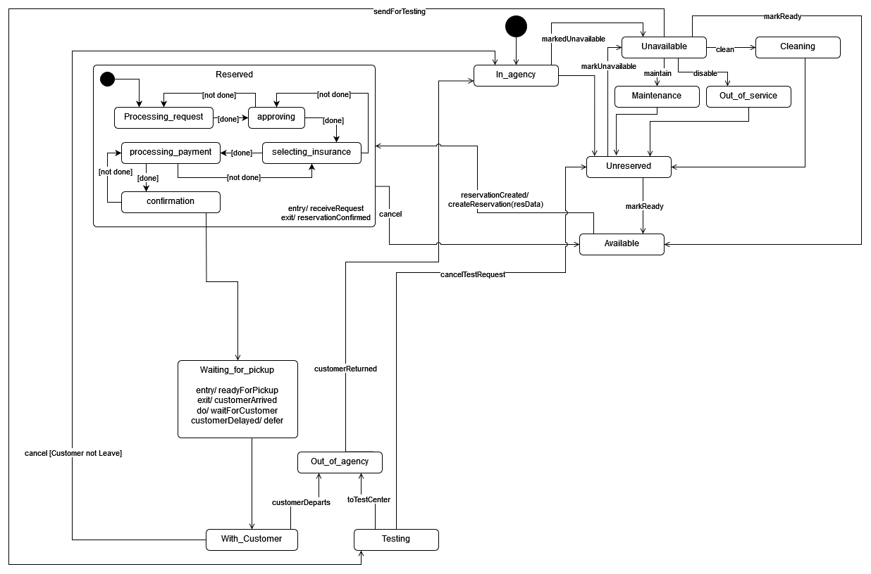

**Rationale:**

States:

1. **In_agency**: The vehicle is back on the property, but has no other state
   1. → Unreserved: naturally goes to this state after being received on property
   2. → Unavailable: markUnavailable - Vehicle arrives on property and is flagged for reason to not become available
2. **Reserved**: The Vehicle has been reserved and cannot be used for another reservation
   1. → Waiting_for_pickup: naturally goes to this state after being reserved and is ready for pickup
   2. → Available - cancel - occurs when a reservation is canceled
3. **Unreserved**: The Vehicle is unreserved, but may not be available for reservations yet.
   1. → Available: markReady - transitions to this state when the Vehicle is approved to become available again.
   2. → Unavailable: markUnavailable - Vehicle has been flagged for additional work to be done
4. **Waiting_for_pickup**: Reservation time has begun, but customer has not picked up the Vehicle yet
   1. Has entry action of ready for customer to pick up Vehicle
   2. Has exit action of customer arriving to pick up the Vehicle
   3. Will wait for customer until they arrive
   4. The deferred state will occur if a customer is late to picking up the Vehicle
   5. → With_customer: naturally goes to this state when the customer arrives
5. **With_Customer**: Customer has picked up the vehicle, but has not left the property yet
   1. → Out_of_agency: customerDeparts - goes to this state when the customer leaves the property with the Vehicle
   2. → In_agency: cancel [Customer not leave] - ]goes to the state when the customer cancels the reservation (which is also triggered if customer does not arrive) without taking the Vehicle off of the property. This is the guard condition
6. **Out_of_agency**: The Vehicle is no longer on the property
   1. → In_agency: customerReturns - transitions to this state when the customer returns at the end of their reservation
7. **Testing**: Some states require yearly testing at authorized locations (example: CT has emissions and MA has state inspection)
   1. → Out_of_agency: toTestCenter - transitions to this state when an employee takes the Vehicle to a testing site
   2. → Unreserved: cancelTestRequest - transitions to this state if the Test was requested in error
8. **Available**: Vehicle is ready to be reserved
   1. → Reserved: reservationCreated/ createReservation(resData) - a customer creates a reservation (hence the createReseravtion action to initiate the transition)
9. **Unavailable**: Vehicle cannot be reserved as it is scheduled for maintenance, to become out of service, or for cleaning
   1. → Maintenance: maintain - Vehicle is sent for maintenance
   2. → Out_of_service: disable - Vehicle has been disabled and not ready to be reserved for a given period of time
   3. → Cleaning: clean - Vehicle is sent for cleaning
   4. → Available: markReady - determined the Vehicle does not need additional service and is ready to be reserved
   5. → Testing: sendForTesting - Vehicle is prepared to be taken to be tested
10. **Maintenance**: The Vehicle is being repaired by an in-house mechanic
    1. → Unreserved: naturally transitions to this state after cleaning
11. **Out_of_service**: The Vehicle is either decommissioned or temporarily not available for reservations
    1. → Unreserved: naturally transitions to this state after being returned to service
12. **Cleaning**: The Vehicle is being cleaned.
    1. → Unreserved: naturally transitions to this state after being cleaned

**Substates**:

1. Reservation (sequential): Each substate has a guard action that allows the process to continue if the user has finished all required pieces of the current state (done). Otherwise, it will return the current state for the user to complete (not done)
   1. Processing_request: System has received a reservation request and is processing. This puts the Vehicle in the Reserved state.
   2. Approving: The contract is being approved and validated that the customer can rent the Vehicle
   3. Selecting_insurance: The customer is selecting insurance package
   4. Processing_payment: The payment is being processed
   5. Confirmation: The reservation is confirmed and the customer is given a confirmation number

The customer can cancel at any substate and will exit from the Reserved state

The entry action occurs when the system receives a request for a reservation for the vehicle

The exit action occurs when the system outputs a confirmation number

